Introduction
Foundation re-use as a mechanism for the preservation of buried cultural heritage in urban centres: how new engineering research helps limit archaeological damage.
Jim Williams¹, Antony Butcher²
¹ English Heritage, UK
² Building Research Establishment, UK

Keywords: Foundation re-use, archaeological deposits, preservation in situ.

This paper achieves the main aim of the conference, as it ‘assesses the impacts of results achieved in previous EC research projects in relation to cultural heritage’. In particular it focuses on how archaeologists (cultural heritage managers) are exploiting the results of a project principally conceived with a much wider environmental sustainability agenda. This paper was presented in the session “Innovative Applications and New Ideas”, which focused on the exploitation of EC-supported research results. The EC project is part of the 5th Framework Programme “cultural heritage and the city of tomorrow”. The project is RuFUS (Re-use of Foundations for Urban Sites). This paper addresses the session themes as it ‘highlights the complementary nature and synergy between cultural heritage and environmental issues’ and is written jointly by an end-user (JW) and the RuFUS project manager (TB), who come from different disciplines, cultural heritage and civil engineering respectively.

To tackle this subject effectively, this paper will first outline the cultural heritage issues that exist in urban centres, before summarising the main findings from the project and how it benefits cultural heritage. Finally we will consider how the lessons learned in the project can be applied in practice, through reference to a case study and a spin-off project in the UK.

Managing below ground cultural heritage assets in urban centres
Many modern urban centres have a long history that reaches back hundreds and sometimes thousands of years. As towns and cities grow larger, the areas of previous habitation, industry and recreation are either retained as part of the evolving cultural landscape, or are removed and replaced with new buildings, This is not a modern phenomenon, and applies just as readily to the past two thousand years or so, as it does today. Before the last century, when buildings were replaced, little modification of below ground remains usually took place. Instead, new buildings were constructed on top of the demolition rubble and previous foundations of the old ones. This left a complex and often deep legacy at the heart of many urban cities. These archaeological remains when excavated yield information about the history of the area and its people. Such remains are also a cultural asset that need to be managed, sustainably.

Unlike previous centuries, redevelopment in the last fifty years has had a much greater impact on below ground deposits. As buildings grow taller and larger they need deeper, stronger and more numerous foundations. Requirements for services on a large scale (sewerage, electricity etc), and items such as lifts, as well as basements all impact on below ground sediments to a much greater degree than in the past. The rate of development has also quickened and this is particularly the case in major cities where the average life span for large offices is 30-40 years. Set within this context one has to question what is the most sustainable way of managing these important cultural heritage assets.

Given the pace of development, there are a number of reasons why the total excavation of every single site before construction may not be appropriate. Firstly, large scale urban excavations are time consuming and expensive to carry out properly. Currently there are also probably not enough well trained staff to excavate, analyse or publish every single urban site that is redeveloped; or perhaps the capacity to curate all of the finds and make a reasonable selection of them accessible to the public. There is also the potential that future techniques will improve evidence recovery, and crucially for archaeologists, if it is all dug up now, there will be no work in the future! Finally, as archaeology is a finite resource, it is arrogant to assume that we as a society, or as archaeologists have the right to consume all of this resource and pass nothing onto future generations. A balance therefore has to be reached between investigation and preservation. However, preservation cannot, in most instances, take place to the exclusion of development, otherwise most of today’s modern cities would become fossilised, with sites left undeveloped. One solution is to find a foundation design where one accepts a small proportion of the site will be lost, but the rest is preserved in situ beneath the development.

The policy context for preserving below ground cultural heritage
The rationale of in situ preservation is expressed in both European and national government policy. The European policy context is the ‘European Convention on the Protection of the Archaeological Heritage (revised)’ [1]. This legislation was drawn up in Valletta, Malta in 1992 and is usually referred to simply as the Valletta Convention. It provides, in effect, a common European policy for archaeological protection. The most relevant sections are Article 4 ii, which requires states to make provision “for the conservation and maintenance of the archaeological heritage, preferably in situ” and Article 5 iv, which requires states “to undertake to make provision, when elements of the archaeological heritage have been found during development work, for their conservation in situ when feasible”. This suggests that these sites should have a longevity beyond their current stage of redevelopment.

In England, this policy is similarly stated in the Government’s Planning Policy Guidance note 16 - Archaeology and Planning [2], commonly referred to as PPG16. This places the onus for dealing with archaeological remains identified during the course of redevelopment with the developer, and more importantly, recommends that where nationally significant remains are encountered, there should be a presumption in favour of their physical preservation. This national policy is mirrored by local planning policies that promote preservation in situ of nationally important remains, see Leicester case study, below. When sites are encountered during development, these policies are used by local planning authority staff, and the developer’s archaeological consultants to produce a strategy to retain as much as possible of the site’s archaeological remains and deposits, whilst still ensuring that development can progress.

Most English planning authorities are provided with archaeological advice from internal or occasionally externally contracted staff. They will advise the planners on the potential for the presence of archaeological remains on any proposed development. In many instances, the developer will have discussions with these archaeological staff in advance of submitting any planning application, although in the absence of pre-determination discussions, planning conditions relating to archaeological works will be applied. The first stage of the process is to evaluate the potential of the site. This is carried out using both non-intrusive desktop and intrusive site evaluations, to help characterise the nature of the below ground deposits. At this point, decisions will be made as to the significance of the remains and the practicalities of their long-term preservation, resulting in a foundation design aimed to achieve the preservation of that largest possible amount of the archaeological remains, an excavation to record these remains, or the refusal of planning permission.

Development impacts on archaeological remains
It would be an oversimplification to suggest that one can simply engineer a foundation without causing damage to any archaeological deposits. In a paper to the 5th EC conference, Williams and Corfield [3] highlighted the potential impacts on archaeological sites and artefacts from construction activities. Such impacts can occur at four stages of the construction process, from pre-construction ground investigation, and site preparation activities, through to the construction work, and later remedial and maintenance work [4]. In this current paper, the development impacts covered relate to the construction stage only.

From the late 1980s onwards, developments in England began to utilise engineering methods to avoid other more expensive ways of dealing with archaeological material, such as total excavation. When the Government’s planning guidance was published in 1990 this added further impetus to a move to excavate less, and preserve more in situ. At about the same time, the City of York had undertaken a study to look at the best way of managing their archaeological heritage [5]. One of its main recommendations was that an adequate balance between the needs of current development and the desire for preservation could be met through using piles, so long as their impact on the site was limited to 5%. Similar approaches were used throughout the country, but archaeologists began to question whether these methods really did provide adequate levels of preservation [6].

These concerns related to a number of issues. Firstly, where only limited pre-construction characterisation of the site has taken place, it is impossible to know what types of archaeological remains might be impacted by piling; it would not, for example be appropriate to pile through a cemetery [7]. Secondly, it is clear from the limited excavation carried out on previous foundations that some techniques are more damaging than others [4, 6, 8]. In some cases, more physical damage has clearly taken place than was anticipated [9, 10], and the assessment of chemical impacts, which may leave little physical trace, is difficult. Most evidence suggests that the impacts from driven (displacement) piles are greater than other techniques and their extent more difficult to predict. Excavations and laboratory analysis has so far shown that disturbance adjacent to driven piles can range from one to three pile diameters [9, 11, 12], covering an area up to nine times the size of the original pile. Thirdly, piles are rarely installed on their own, and impacts therefore accrue cumulatively from the placement of piles in groups (where deposits in between the piles become inaccessible for future evaluation), and from the construction of ground beams and other elements that connect the superstructure to the foundations. Finally, when sites with existing piles are re-developed, if more piles are used, then the proportion of the site that is subsequently left preserved will reduce.

A solution is RuFUS
Although the section above suggests that for the last fifteen years, archaeologists and developers have been preserving the majority of the archaeological remains of a given site through the use of piled foundations, it should be emphasised that this also occurred during the previous few decades. However at that time there was less awareness of cultural heritage issues, and no robust statutory framework for dealing with archaeological remains encountered during development. As a result, there are many sites within urban centres in England, and presumably other European countries where archaeological sites lie unintentionally buried beneath modern buildings. When these sites are made available for re-development, re-using the previous foundations would obviously reduce further potential impacts on the buried archaeological deposits. Equally, where sites are preserved in situ in the present, it is important that adequate documentation is made, so that these piles can be re-used in the future.

There are many reasons aside from the protection of cultural heritage why foundation re-use might be appropriate or necessary on a given site. These include environmental drivers supported by legislation, and the promotion of sustainability, as well as the changing economics of construction. Environmental issues include reductions in the use of new natural resources and the quantity of waste produced from demolition and construction, as well as concomitant reductions in vehicle and plant movements. Economic drivers include lower energy and natural resource costs, as well as the expected future increase in the costs of the disposal of demolition debris, including for example congestion charging and other transport costs. Some of the financial considerations of foundation re-use are shown in Table 1.

Savings | Extra costs
Ground Investigation | Investigation of existing foundations
New foundation design | Remediation of existing/additional foundations
New foundation construction | Redesign/relocation of superstructure
Spoil disposal | Interfacing with new superstructure
Raw and processed materials | Environmental impact of operation of new building
New foundation construction time
Environmental impact of new foundations
Table 1. Costs to be considered in re-use of foundations, from the RuFUS handbook [13].

The biggest driver for the re-use of foundations is ground congestion, and this will become an increasingly important issue in the coming centuries, particularly in large urban centres where below ground constraints can include services and transport, as well as previous foundations, as can be seen in Figure 1. Archaeological remains add yet another element to an already complex picture.

In many cases it is theoretically possible to re-use foundations. However, for this to work in practice, a number of technical considerations must be met. The locations where piles are needed must be compatible with the existing foundations, and they must have a sufficient capacity to carry the new load. Additionally, it will be important to verify that the old piles are in good condition, and would operate as effectively as new ones.

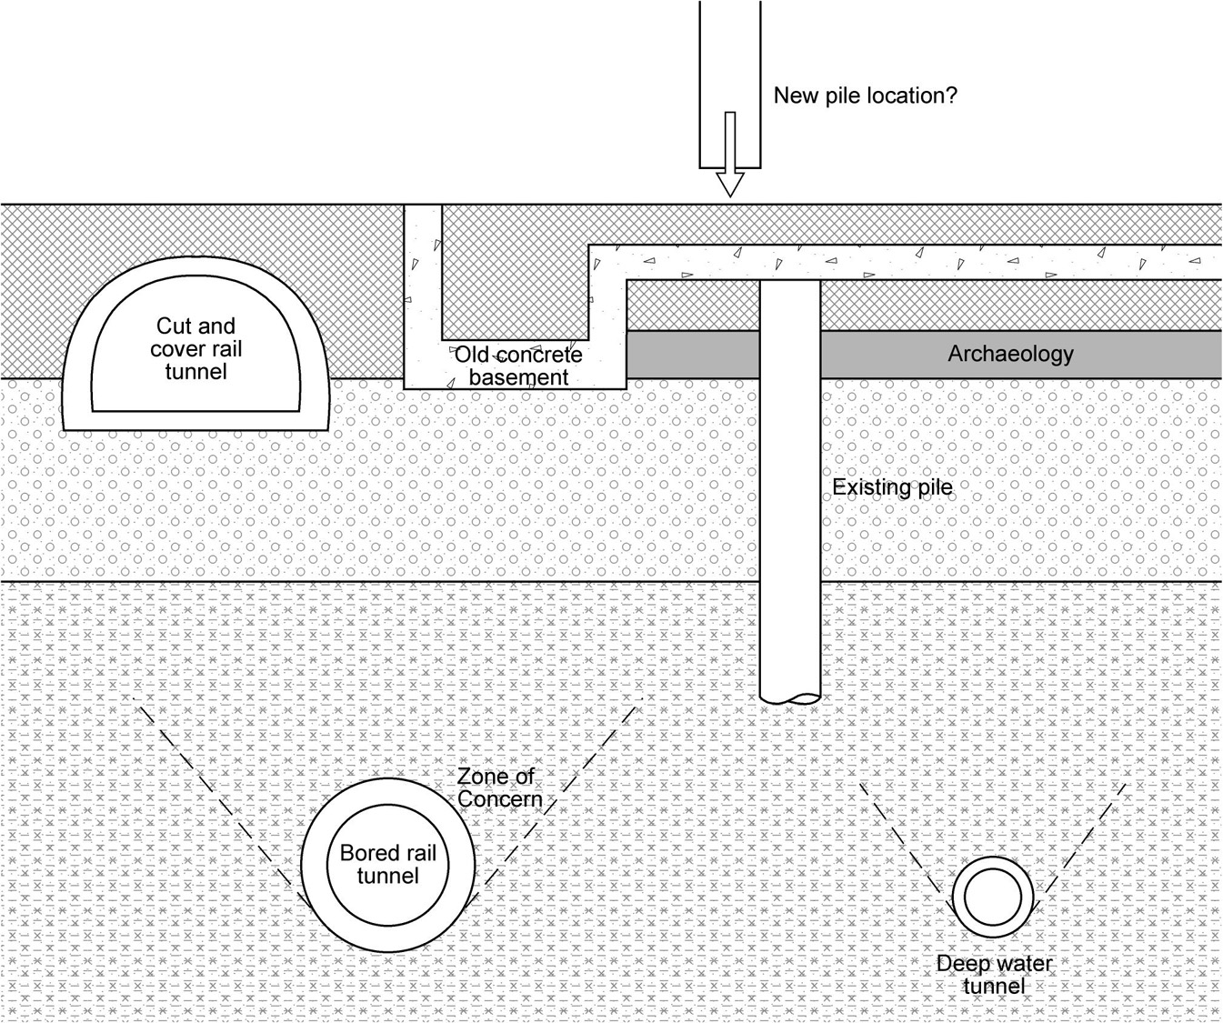
Figure 1: Problems of ground congestion are a key driver for the re-use of foundations. This image shows some of the potential below ground obstacles faced in urban centres. Image from the RuFUS handbook [13].

Major new research elements
The principal new research outputs from RuFUS include,
- advances in risk modelling and decision models
- advances in non destructive testing for integrity of foundation materials and foundation geometry and capacity
- Foundation capacity enhancement and the exploitation of under utilised capacity
- Future proofing new foundations

The re-use of foundations has many implications that need to be understood at the earliest stage of a re-development project. To assist in the consideration of these implications new decision models have been developed for use by clients/developers and their construction professional advisors. These decision models consider risk, economics, environmental impact and whole life costs and will help highlight both the benefits of a re-use of foundations strategy and its possible consequences.

The assessment of existing foundations is key to understanding their likely behaviour if re-used. Significant advances have been made in the detection of the geometry of foundation slabs and piles. The latest systems can now detect the thickness of foundation slabs up to over 1m thick including two layers of reinforcing that in the past would not have allowed the full thickness of the slab to be determined. The detection of pile lengths using seismic waves has also been developed into a rapid and cost effective technique. In addition the understanding of rapid pile testing methods (under used in Europe), for capacity has been significantly improved by comparative testing.

The foundations that are currently assessed to be re-used were all designed typically over 30 years ago and the understanding of soil structure interaction and complex foundation systems has advanced considerably over that time. This situation allows for re-analysis of existing foundations that will frequently allow an upgrading of the foundation capacity. Furthermore, time dependent effects on foundation capacity are now better understood and can under certain circumstances also allow upgrading of foundation capacity. These advances, together with enhancement systems such as mini-pile groups that surround an existing pile, can enable the re-use of foundations with significantly less cost in time, economic and environmental impacts than the installation of new foundations and particularly the removal of existing foundations before replacement by new foundations.

The future re-use of foundations should be considered both when installing new foundations or re-using existing foundations. To future-proof these foundations they need to be documented and an understanding of their behaviour gathered. The RuFUS project developed a documentation system to record all the necessary data to enable a foundation to be re-used and new ‘smart’ instrumentation that can monitor a building’s behaviour during its life thereby demonstrating the foundation behaviour and its potential for re-use.

All of these project elements will be reported within a best practice handbook [13] (the RuFUS handbook), which will provide an easy to use guide to foundation re-use for clients and developers, as well as engineers and other construction professionals.

How foundation re-use benefits cultural heritage
There are many sites in England, and presumably Europe where piles have been installed into archaeological deposits, inadvertently preserving the majority of these sites in situ. Re-using these foundations when the sites are redeveloped will allow this in situ preservation to continue. It may not always be possible to re-use all of the foundations, and even if total re-use is achieved, some new piles may still be needed. This would still represent a reduction in the total number of new foundation elements used, allowing a greater proportion to be preserved than if only new piles were used [14]. As well as sites which have been accidentally preserved in situ, in England there are those (post-1990) where a piled mitigation strategy has been used. On these sites, piles have deliberately been installed to leave the rest of the site preserved. In order to continue to preserve this site the next time it is redeveloped, these piles should be re-used.

Unfortunately, the archaeological community has only lately, with notable exceptions [5], come to realise the potential for foundation re-use, and no coherent strategies are in place for the long-term curation of either basic information such as which sites have been preserved in situ, or more complex engineering data that would allow future re-use. This is a problem that exists across the board, and the lack of records for currently standing buildings and their foundations is one of the biggest problems that is faced by those wishing to undertake a pile re-use programme. Therefore as part of RuFUS, a list of the types of information that should be curated from each new construction project has been drawn up, see Table 2. Whilst this has wider implications outside the sphere of cultural heritage management, for sites where archaeological remains are preserved in situ, it is essential that this information is retained, perhaps with the archive from the site, so that future re-use can be more easily achieved.

Program stage | Design stage | Construction stage | Building operation
Geological info  Geotechnical info  Groundwater level  Groundwater quality  Contaminated soil  Site conditions | Design philosophy  Design codes  Design calculations  Necessary bearing capacity  Force combinations applied on each pile  Pile data  Settlement limitations  Protocol for foundation records | As-built documents  Non conformance reports  Construction documents  Programme of piling works  Plant and equipment  Test piling  Working documents  Site records  Pile installation records  Effects on nearby foundations and structures  Results from monitoring | As-built drawings  Maintenance records  Environmental changes  Inspections  Pile behaviour  Service life measurements  Structural alterations
Table 2. Information relating to new piles that should be stored to ensure that pile re-use can take place the next time the building is developed, from the RuFUS handbook [13].

Applying RuFUS in practice
Buildings are usually designed first by architects, who then engage civil engineers to design the foundations around that structure. In particularly congested locations, this may be a significant challenge for the engineers, see for example Figure 2. For foundation re-use to be more readily acceptable and regularly used, this way of working needs to change. For large and complex urban sites, the design of any new building should start with a thorough below ground characterisation, and consideration of whether foundation re-use would be technically feasible. Once those parameters are set, they can be introduced to the architectural design team as a starting point for the design.

Intriguingly, it is often the potential costs of dealing with archaeological deposits, rather than the potential complexity of previous foundations, or the other environment costs that has led developers to re-use foundations, as is demonstrated by the following two case studies. Aside from these two examples, there have been at least two other sites where foundations have been used to reduce damage to archaeological remains. These were at 22-24 High Street, Colchester, Essex [15, 16], and The Collection, Lincoln [14, 15].

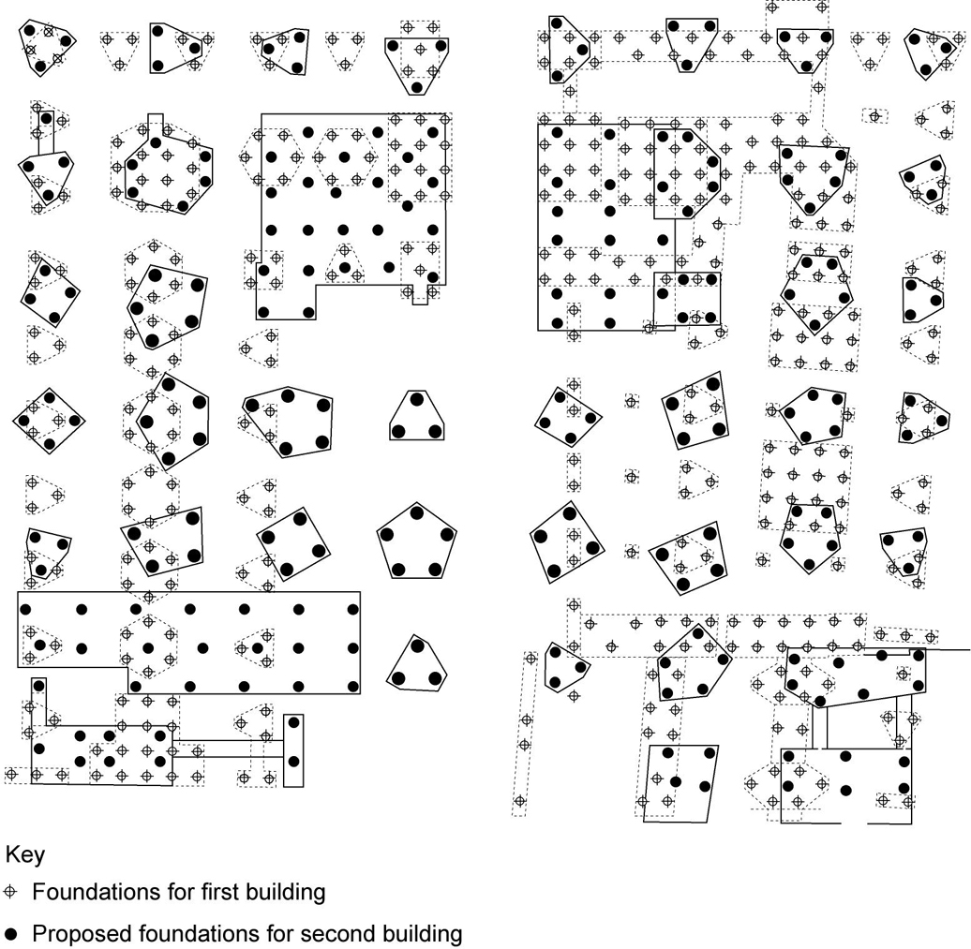
Figure 2. Ground congestion from a first set of piles limiting locations for a second set of piled foundations. This will become an increasingly common occurrence on large urban sites. Image from RuFUS handbook [13].

York
A study carried out for the City of York in 1991[5] and adopted as planning policy makes recommendations about how best to achieve preservation in situ. One of its recommendations is that good record keeping is essential for the future re-use of foundations installed to preserve archaeological deposits. Since this report was produced, there have been a number of sites where the potential to re-use foundations has been considered, and for the redevelopment of any building constructed from the 1960s onwards, the City Archaeologist always suggests to the developer that they consider the potential for pile re-use. So far, four sites that fall into this time period have been considered (J Oxley, pers. comm.). Of these, two of the developers were reluctant to go ahead with re-use schemes because of issues of insurance / liability, and questions over the validation of pile integrity. A further scheme also did not come to fruition.

The fourth site is the former Victoria House Co-op building, on Micklegate, which is now the Ramada Encore Hotel. The original building on the site was owned by and housed the Yorkshire Co-operative society, and was constructed in the 1960s. It was a fairly simple design, with internal columns that transferred the load of the structure directly to the foundations below, which were set out in a regular grid. In the late 1990s the site was purchased by George Houlton and Sons Limited, for development into a hotel. In early consultation discussions with the City Archaeologist the developers were alerted to the likely archaeological constraints of the site, which lies within the medieval city walls, in an area where well preserved and potentially waterlogged archaeological remains were likely to be present. To reduce the financial costs of dealing with the archaeology, the developers themselves suggested that they could build off the existing foundation slab, thereby protecting any archaeology in situ. In one location, the piles were broken out and a pile test was carried out, which demonstrated that the piles would be suitable for re-use. A limited number of new piles were needed for additional building elements, but these were kept to a minimum, and were only located in two small areas of the site, and were a small proportion of the total foundation elements on the site (13% of the total 127 piles). The areas where these piles and their caps were inserted were subject to a watching brief, as were a small number of service trenches, but these only impacted on post-medieval deposits, that in this case were not of any particular significance[17].
Having opted for a scheme that included the re-use of foundations, this decision then affected the rest of the design programme of the hotel, which had to fit around the existing foundation plan, and therefore to a large degree the former building shape. The ground floor area now contains two separate retail units (unrelated to the hotel) and a large, and open hotel lobby. The upper floors contain the 104 bedrooms of the hotel, and a restaurant. Because of the constraints of the site, the architects had to move away from the standard ‘Ramada Hotel’ specification, and design the hotel to fit around the existing space (D. Padden, pers. comm.), which they have done very successfully (J. Williams personal observation.).

Leicester
The City of Leicester, UK, is currently undergoing substantial regeneration, in many cases in areas containing deeply stratified and complex archaeological deposits. Much of the development is planned for an area that has until recently been somewhat peripheral to the current city centre, but was in fact the location of the walled medieval, and before that Roman town of Leicester, and is identified as an archaeological alert area in the Local Plan [18]. It has been estimated that the current redevelopment programme covers an area of about 12% of the walled town (R Buckley, pers. comm.). A number of the buildings that have been re-developed or are earmarked for re-development were constructed at some point from the 1950s to the 1970s and are therefore likely to be founded on piles, that maybe suitable for re-use. Given the potential presence of significant archaeological remains, and the costs that would have to be expended in adequately dealing with them, the developers have already carried out pile re-use feasibility studies at two locations in recent years. Unfortunately, neither could be used, due in part to the constraints of the pre-existing design of the new development.

Given the pace of regeneration, and the importance of the archaeology, the City Council has recently commissioned a project to raise awareness of foundation re-use and provide guidance to encourage developers to consider it on all relevant sites, but also to ensure that on sites where archaeological deposits are preserved in situ through the use of piles, that an appropriate record is kept so that these piles can be re-used in the future. The project is being carried out by the Building Research Establishment, drawing on experience gained from RuFUS, and will result in the production of a short guidance leaflet aimed at developers in the city. It will highlight the benefits of foundation re-use, in particular the lower foundation construction costs, and most importantly, reduced costs for dealing with archaeological remains. It will link clearly into the City’s existing Local Plan policy relating to archaeology, ‘BE01 – preservation of the City’s archaeological heritage’. This policy states that ‘the City’s archaeological heritage will be preserved where appropriate by ….. c) negotiating amendments to submitted schemes to preserve archaeological remains in situ, and generally minimise the impact by appropriate siting, foundation design and location of services and associated landscaping’ [18].

The project will also emphasise the need to curate recent and future foundation information, as described in Table 2. Some of this information is currently already required by the City Archaeologist in order to enable the archaeological assessment of the site. This is detailed in a standard planning condition that reads:

'Before the development is begun, a detailed design and methods statement and archaeological impact assessment including existing and proposed ground levels showing the layout and depths of all foundations, services, trenches, drains and other ground works, and all revisions of such, shall be submitted to and agreed in writing with the City Council as local planning authority. No development shall take place except in accordance with the agreed details….’ (C. Wardle, pers. comm.).

This guidance note will be used by the Leicester Regeneration Company to target future developers, to encourage them to consider foundation re-use, and also by the City Archaeologist to encourage developers to adhere to the standard condition on archiving information so that future re-use may be achieved. It will be a clear and demonstrable spin-off from the RuFUS project that will hopefully work at a local level to drive forward foundation re-use as a viable option, and one that helps to ensure that suitable documentation is available so that sites preserved in situ in this phase of re-development, can be considered for further preservation through foundation re-use in the future.

Conclusions
Currently no published single source of information exists in the format that will be produced for the RuFUS handbook [13], and this has had major implications for the past uptake of foundation re-use schemes. The work carried out in project RuFUS has made significant progress in providing mechanisms that will help to promote foundation re-use in the future. These include decision models for project management of foundation re-use projects, and risk models to investigate associated financial risks. Equally, innovative approaches have been made in relation to non-destructive testing of piles to assess integrity and geometry. Recommendations have also been produced for ways in which the ‘in service’ history of piles can be measured, giving an even more accurate quantification of their future re-use potential.

It is likely that a general upsurge in foundation re-use and improved acceptance of it as a viable technique will increase the numbers of archaeological sites where these issues are considered, and the detailed sections on archaeology within the RuFUS handbook will give greater emphasis to this topic. This is not to say that this is by any means, a problem solved. Although most EU countries are signatories to the Valletta Convention [1], the ways in which this legislation is reflected in national and local planning documents will doubtless be different from the English examples given here. However, the principal results and methods of this project are applicable and transferable to any country, as are the main problems. Currently the most pressing need in England is to ensure that where archaeological remains are preserved in situ using piles, that the information listed in Table 2 above is collated and curated so that these piles can be re-used in the future.

In the introduction we highlighted the fact that this paper would assess the impact of an EC research project in relation to cultural heritage. It is clear from the information presented that the research carried out in RuFUS will greatly enhance our understanding of foundation re-use, and in particular its application on sites containing preserved archaeological remains. The results of the study are not restricted to England, or the other project partner countries, and will provide benefits to all wishing to find sustainable ways in which to preserve cultural heritage.

European Project Details
RUFUS, EVK4 – 2001 - 00289, Re-Use of Foundations for Urban Sites, Antony Butcher, BRE; The project is managed by the Building Research Establishment (UK). The other partners are ARUP (UK), Cementation Foundations Skanska (UK), BAM [Federal Institute for Materials Research and Testing] (Germany), Institute and Laboratory for Geotechnics at the Technical University Darmstadt (Germany), Stamopolous and Associates Architects (Greece), Solentanche Bachy (France), Swedish Geotechnical Institute (Sweden). There is a project web site (www.webforum.com/rufus), where information relating to the project can be found.

References
[1] Council of Europe, 'European convention on the protection of the archaeological heritage (revised), Valletta'. 1992.
[2] Department of Environment, 'Planning Policy Guidance Note 16 - Archaeology and Planning', HMSO, London, 1990.
[3] Williams, J. P. and Corfield, M., 'Construction impacts on in situ preservation of archaeological sites and artefacts', in Proceedings of the 5th European Commission Conference on Research for Protection, Conservation and Enhancement of Cultural Heritage, Cracow, Poland May 2002, Kozlowski, R., (ed.), Polish Academy of Science, Cracow, 2003, pp. 276-279.
[4] Davis, M. J., Gdaniec, K. L. A., Bryce, M. and White, L., Study of the Mitigation of Construction Impacts on Archaeological Remains, Museum of London Archaeology Service, London, 2004.
[5] Ove Arup and Partners and York University in association with Bernard Thorpe, 'York Development and Archaeology Study', 1991.
[6] Biddle, M., What Future for British Archaeology. The opening address at the Eighth Annual Conference of the Institute of Field Archaeologists, Bradford 13-15 April 1994. Archaeology in Britain Conference 1994, Oxbow Books., Oxford, 1994.
[7] The Church of England / English Heritage, 'Guidance for best practice for treatment of human remains excavated from Christian burial grounds in England', The Church of England / English Heritage, 2005.
[8] English Heritage, 'Piling and archaeology guidance note'. in preparation.
[9] Dalwood, C. H., Buteux, V. A. and Darlington, J., 'Excavations at Farrier Street and other sites north of the city wall, Worcester 1988-92', Transactions of the Worcestershire Archaeology Society 3rd Series. 14, 1994, pp. 75-114.
[10] Nixon, T., 'Practically preserved: observations on the impact of construction on urban archaeological deposits', in Preserving archaeological remains in situ. Proceedings of the conference of 1st - 3rd April 1996, Corfield, M., Hinton, P., Nixon, T., and Pollard, M., (eds), Museum of London Archaeology Service, London, 1998, pp. 39-46.
[11] Davies, G., 'Archaeological field evaluation of the impacts of piling at The JunXion, St Marks Street, Lincoln.' Report No 750.1 - unpublished, ARCUS, 2003.
[12] Hird, C. C., Emmett, K. B. and Davies, G., Movement of soil and groundwater around driven and CFA piles in layered ground, Environment Agency, Bristol, 2006.
[13] RuFUS project, 'Rufus Handbook', BRE Press, Watford, in preparation to be published in October 2006.
[14] Williams, J. 'Pile re-use at The Collection, Lincoln: Lessons learnt', in RuFUS conference proceedings, BRE Press, Watford, in preparation to be published in October 2006.
[15] Williams, J. and Chaddock, S., 'Protecting the buried archaeological resource: the re-use of foundations', Proceedings of the 7th International Symposium of the Organization Of World Heritage Cities, Rhodes, Greece, 2003.
[16] Chadwick, P., 'Archaeological Written Scheme of Investigation, 22-24 High Street, Colchester, Essex, Unpublished report CgMs Consulting'. 2000.
[17] York Archaeological Trust, 'The Former Victoria House, Micklegate, York, report on an archaeological watching brief', York Archaeological Trust Field Report No 41. YORYM accession code 2001 10749. 2001.
[18] City of Leicester, 'Local Plan', 2006.

